Assessment Guide for Part-time Instructors
By
Melissa Deadmond, Ph.D., MPH
Associate Dean of Assessment and Planning

As a part-time instructor, you may be asked to participate in formal assessment of your course’s official student learning outcomes (SLOs) according to your department’s established course assessment cycle. Your department chair should inform you at the beginning of the semester if the course you are teaching is scheduled to be assessed.
What is Assessment?
The term assessment can be applied towards different purposes in higher education, but for the purpose of classroom instruction, assessment is the process of systematically collecting, analyzing, and using information to try and improve student learning. Most likely, you already do this in your classroom. When department faculty get together and say: “Students in our course didn’t do so well on X. May we could . . . “ that’s assessment (Walvoord, 2010); formal assessment also asks you to document this process as evidence.
How do I begin?
You should begin by reaching out to your department chair, if they have not already reached out to you, and asking them if your course is scheduled for assessment this semester. In some cases the chair will want instructors in all course sections to use a common assignment, project, questions on exams, etc. for assessment purposes. You will need to implement this into your course curriculum. If there is not a common assessment tool that your chair would like instructors to use, then you will need to develop one or more instruments.
What makes for good assessment instruments?
Good assessment begins with good SLOs that are actionable and measurable. Official course SLOs have been reviewed by TMCC’s Curriculum Review Committee for such attributes, although there may be room for improvement depending on how long ago the course SLOs underwent the review process. Look at your course SLOs, which describe what the student should learn and/or do as a result of their experiences in the course, regardless of course section or instructor. Then, develop an assignment that you can use to evaluate whether students accomplished the learning outcomes. SLOs often include higher level actions such as analyze, compare and contrast, apply, etc., which often lend themselves towards more involved assignments like essays, reports, research papers, demonstrations, or projects rather than multiple choice questions; however, a carefully-crafted multiple choice question might still accomplish these higher order skills. Regardless, it is better to develop your assessment instruments at the beginning, with purpose rather than as an afterthought midway through the semester.
One question often asked is whether assessment instruments should be part of the course grade or maintained separately. The most meaningful assessment of student learning comes from assessment instruments that embedded in regular course assignments (NILOA, 2016). After all, you give these assignments because you think they will help your students to achieve your learning goals. That’s why they are a part of your curriculum. In this way, assignments are authentic artifacts of student learning. We naturally want good information about student learning to inform our actions towards improvement (NILOA, 2016; Walvoord, 2010).
Evaluating Student Learning
When you evaluate student work, you need a set of criteria, or the aspects of the work that will be assessed. Criteria are often incorporated into a rubric that also includes a performance scale that identifies students’ level of mastery within each criterion, and descriptors that are associated for each level of the performance scale for a criterion. TMCC has adopted an institution-wide performance scale of “Unacceptable,” “Marginal,” “Proficient,” and “Exemplary.” You will need to develop appropriate descriptors for each of these performance levels for each criterion that you are using to assess student work. It is important that the descriptors really distinguish one performance level from another for each criterion.
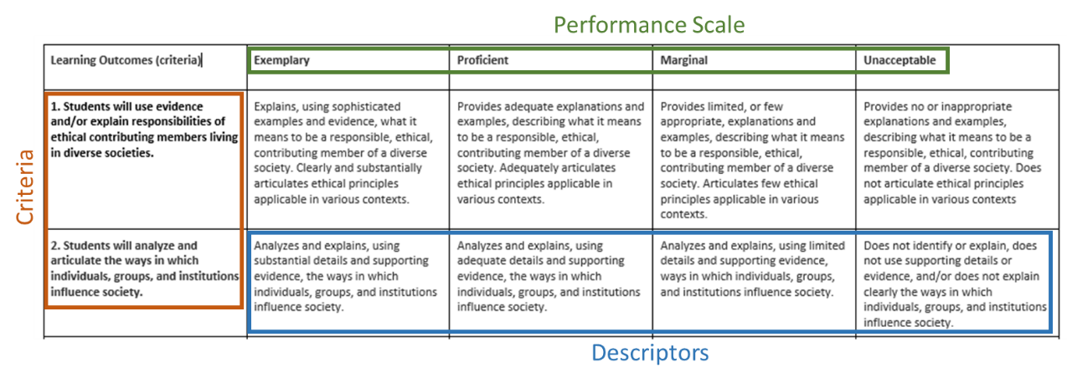
If more than one faculty member will be using the rubric to assess student work, it is important for the department to discuss and develop a shared set of descriptors and a shared understanding of how each will be applied and to establish a scoring consistency among scorers, also known a raters. This process is called norming. In addition to establishing a shared understanding and scoring consistency across the department, norming provides an opportunity for part-time faculty to participate and engage in collegial interaction and idea sharing with other members of their department.
Documenting the Assessment Process
TMCC has recently implemented a new assessment management system (AMS) called eLumen. eLumen is designed to capture assessment data for every CSLO, for every student, and across every course section and then aggregate this data for a course. With thoughtful and deliberate curriculum mapping of CCSLOs to those of a program (degree or certificate) or TMCC’s general education competencies, data can also be aggregated to indirectly assess these learning outcomes as well. eLumen is also capable of incorporating student demographic data so that we can analyze and determine whether there is equity in achieving SLOs across our various student populations. While eLumen is designed with this “every student” assessment in mind, departments may choose to assess a (random) sample of student work across multiple sections.
Documenting the assessment practice in eLumen at the course section level by faculty consists of two pieces, a scorecard, and a section improvement plan. The scorecard is used to assign a score of 1-4 for each CSLO assessed according to the TMCC-adopted rubric of “Unacceptable,” “Marginal,” “Proficient,” and “Exemplary” so that scores can be aggregated to inform program or institutional level attainment of student learning. The section improvement plan consists of three reflection questions for you to provide input for the Course Coordinator, either your department chair or a lead faculty member, to assemble and submit a single course action plan that represents an overall analysis of assessment data and strategies to improve student learning.
Directions for logging in and completing the scorecard and reflection questions associated with the section improvement plan begin on page 4.
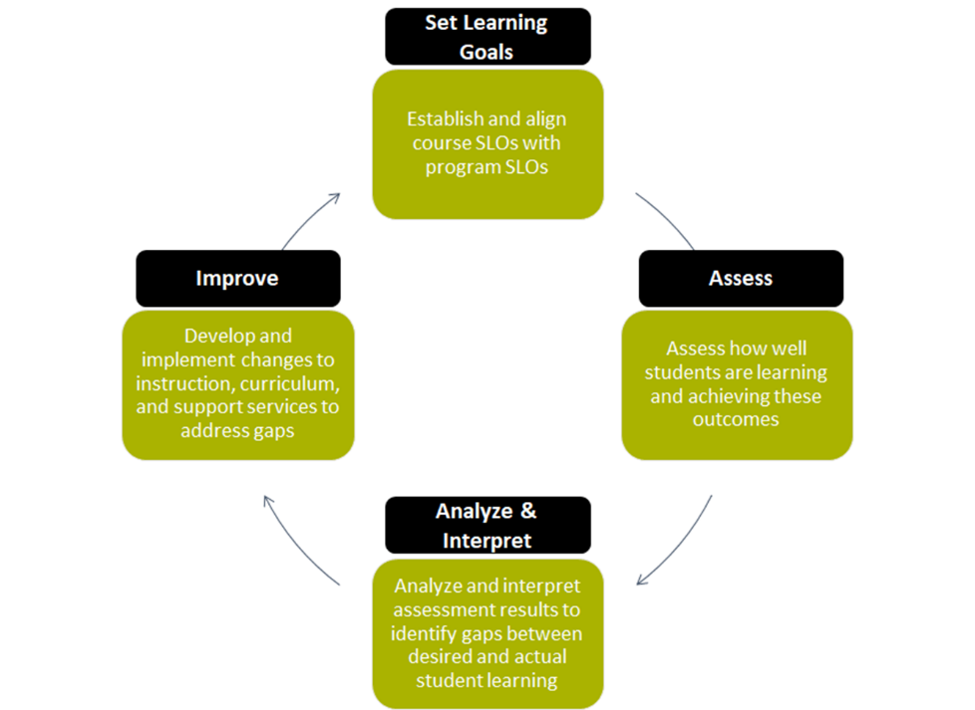
Closing the Loop
The assessment process is often portrayed as a loop because establishing SLOs and collecting data, i.e. assessing, are only the first steps. Good assessment leads to informed decision making in terms of using the data to improve student learning. In other words, the end of assessment is action (Walvoord, 2010). Using assessment information to develop and implement an improvement plan is often called “closing the loop,” which completes the assessment process (and establishes a new round of assessment).
TMCC schedules two official Assessment “Closing the Loop Days” for department faculty to discuss assessment results and develop plans for improving student learning:
- First department meeting of Spring Professional Development Days
- Wednesday after grades are due in May
Part-time faculty are invited and encouraged to attend these planning sessions.

References:
National Institute for Learning Outcomes Assessment. (2016, May). Higher education quality: Why documenting learning matters. Urbana, IL: University of Illinois and Indiana University, Author.
Walvoord, B. E. (2010). Assessment clear and simple: A practical guide for institutions, departments, and general education (2nd ed., pp. 1-11). San Francisco, CA: Jossey-Bass.
Using eLumen to Score Student Work (Faculty)
- Use Chrome or Fire Fox as your browser and access eLumen directly or via the Assessment and Planning website.
Direct access - https://tmcc.elumenapp.com/elumen/
Via the Assessment and Planning Website (http://www.tmcc.edu/assessment/)
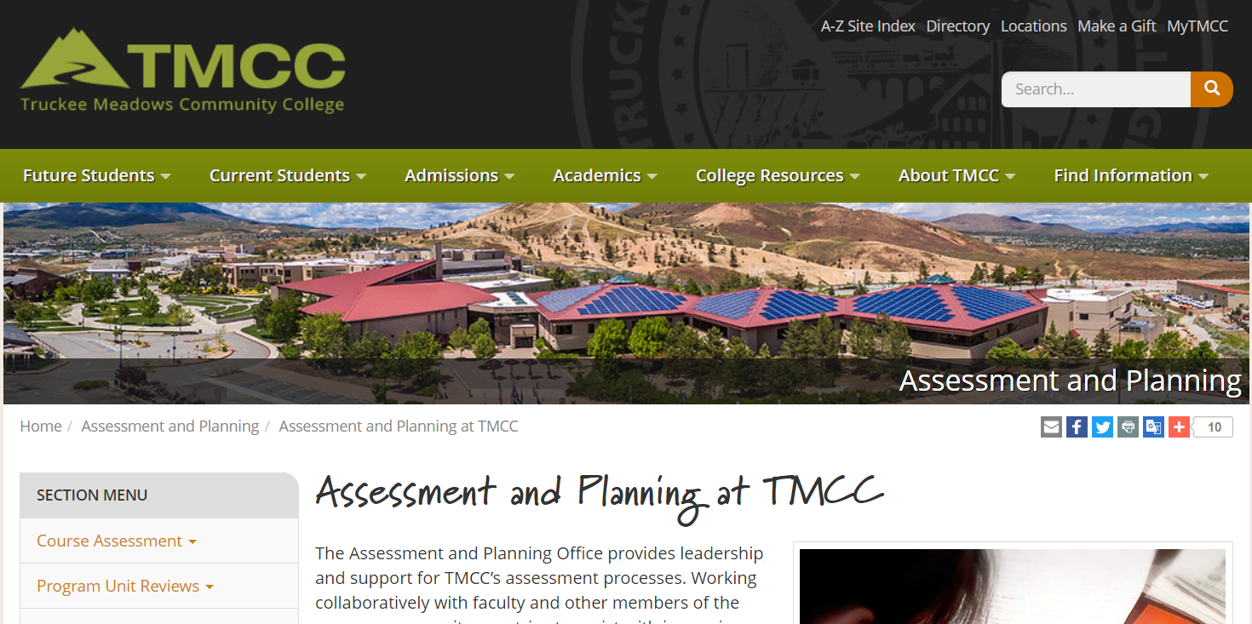
(scroll down)
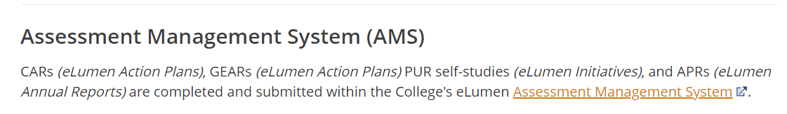
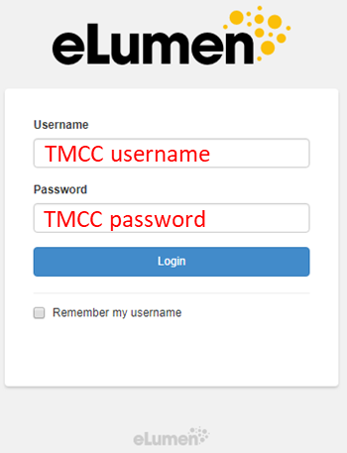
- If they are not selected already, select "Faculty" next to your name and the discipline of the course you want to score*. Click on the Courses tab and select the semester your course was (is being) taught.

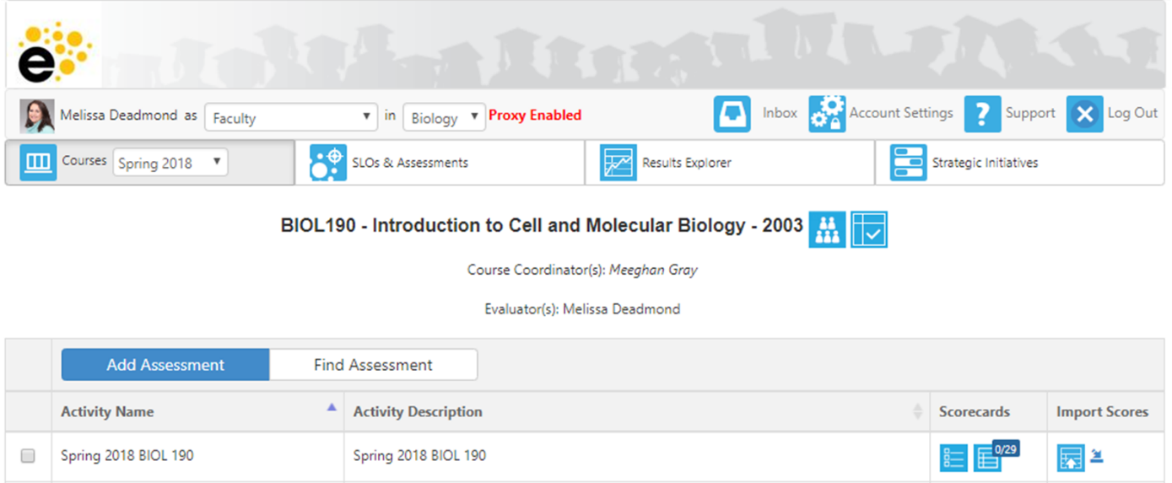

- At this point you should see in the main page the courses in the selected discipline that are available for scoring*. To score the students in a course, click on one of the two blue boxes under "Scorecards".

The left-most blue box connects you to the "Scorecard view.” Here you will see your students and the scoring scale numbers (there will be no definition for the individual grading scale scores). If you have already scored your students, this view will be the quicker one to use.

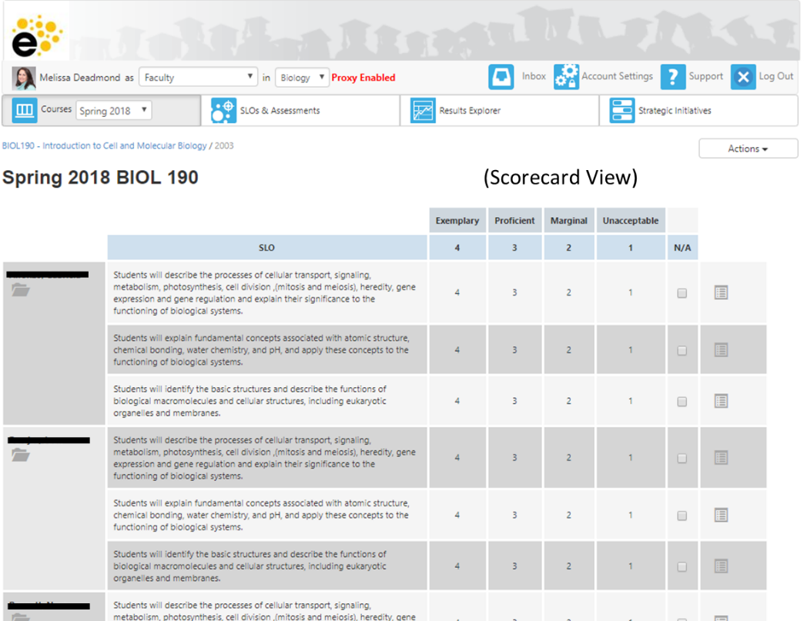

The right-most blue box connects you to the "Rubric view.” Here you will see you students and the entire rubric (the scoring scale numbers AND the definitions for each of these numbers). If you have not yet scored your students, this view is best.

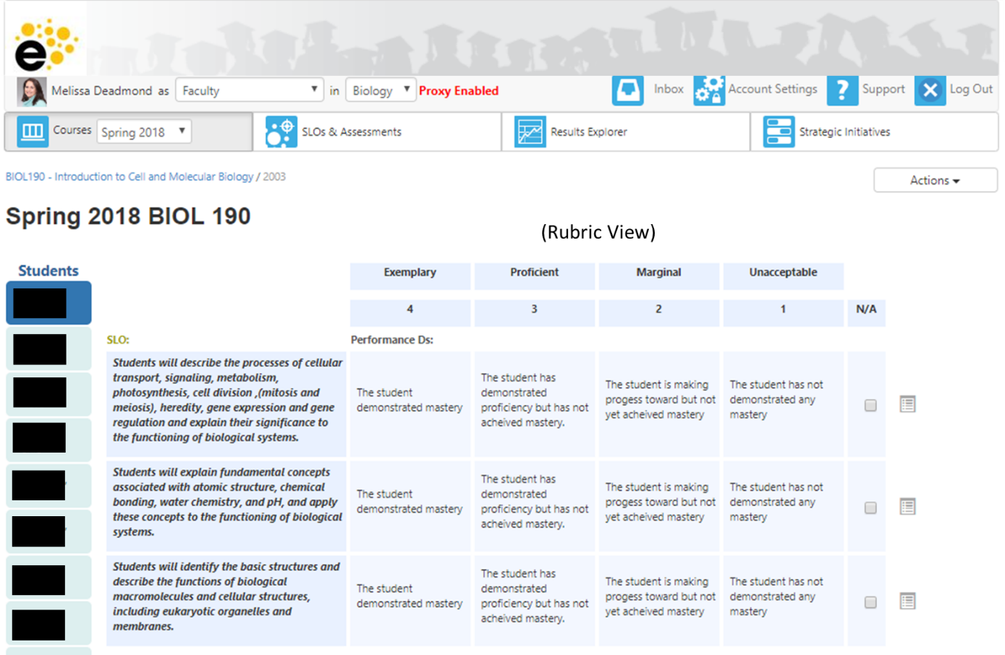

You can toggle between these two views by selecting the alternate view under "Actions.”

The alternate view will be at the bottom of the drop down list:
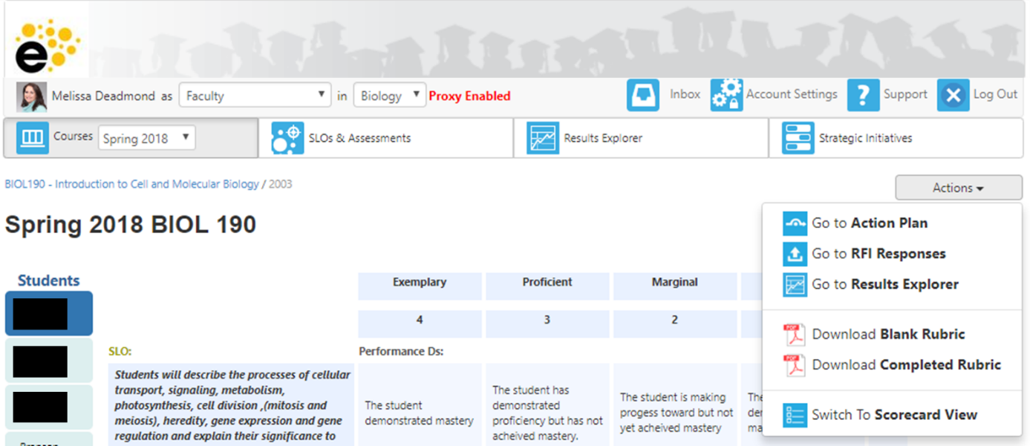

- Click on a score for each CSLO to assign it to a student. To complete your scoring, every student must receive a score (or "N/A" if the student was absent or was no longer enrolled in the course) for every CSLO. Every row that contains a scoring button must have one button selected for your scoring to be complete. If you leave anything blank, eLumen will think you took a break and are coming back to finish the scoring later!

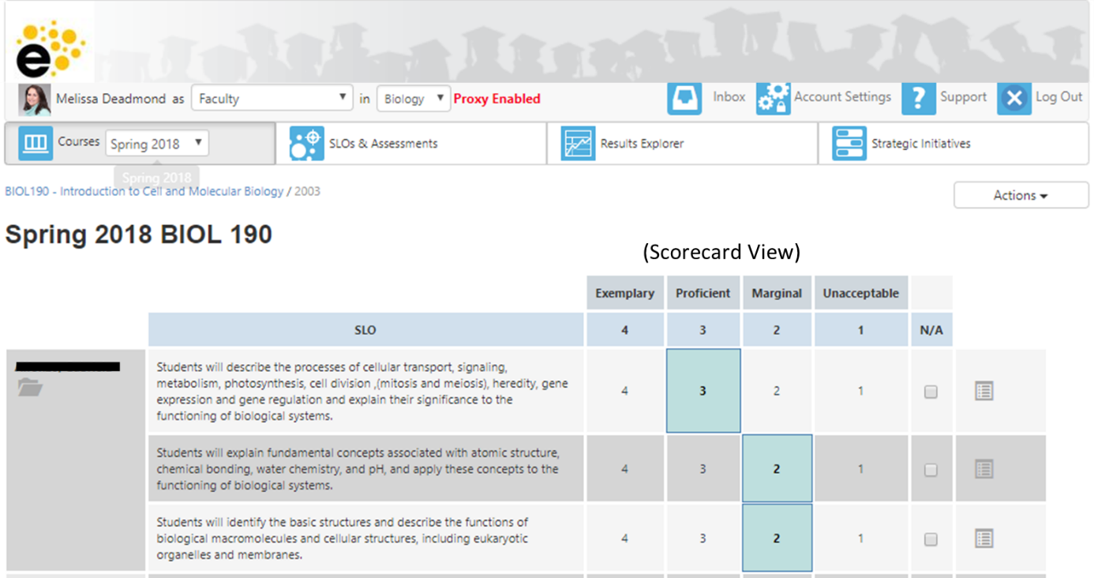

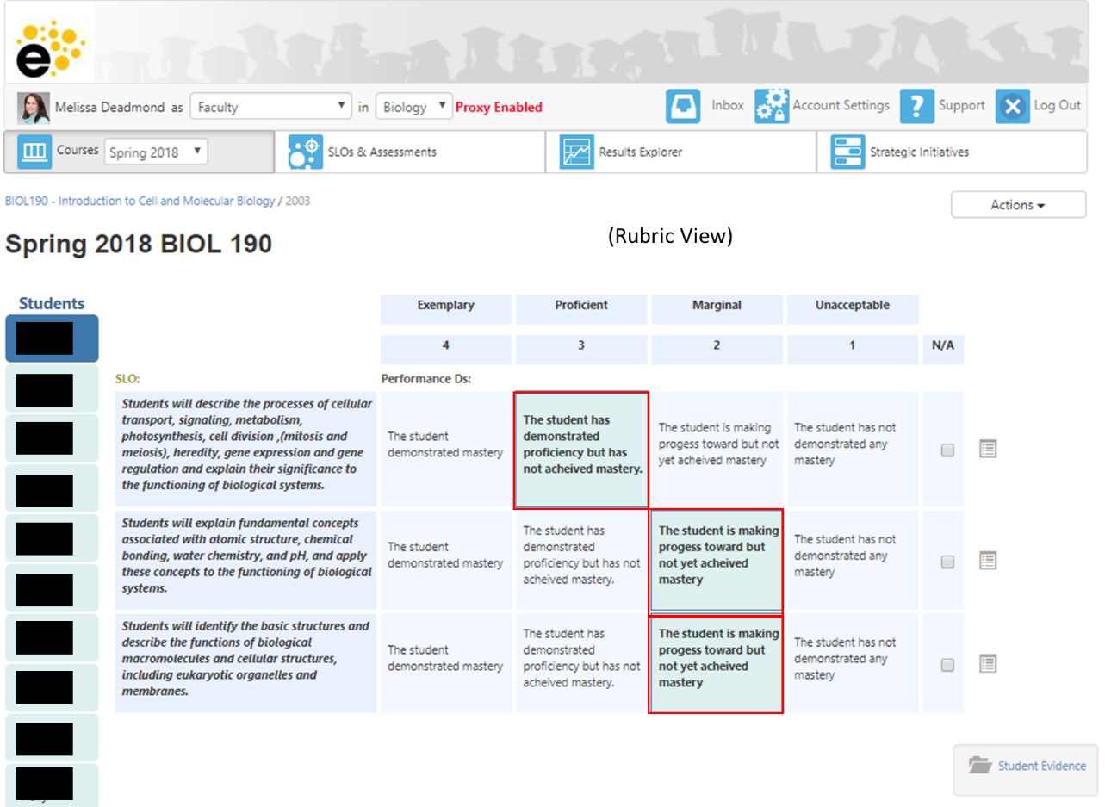

NOTES: If you want to score your students by uploading their scores on a spreadsheet (so you don’t have enter student scores individually), here is a video to assist you!

- If you would like to upload examples of student work (approximately 3-4 per section) as artifacts of assessment, you can do so by clicking on the “Student Evidence” folder in either the Scorecard or Rubric View.

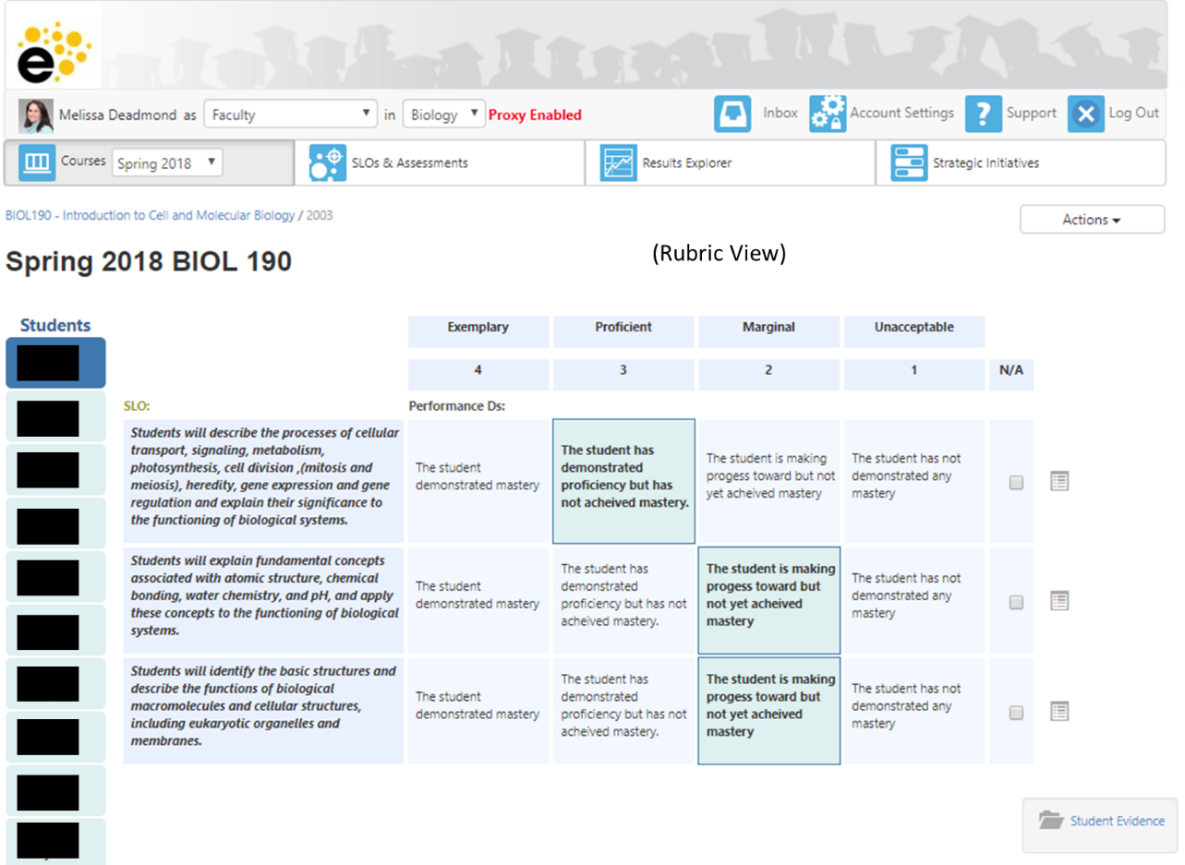
You will first see this prompt. Click on Upload file.
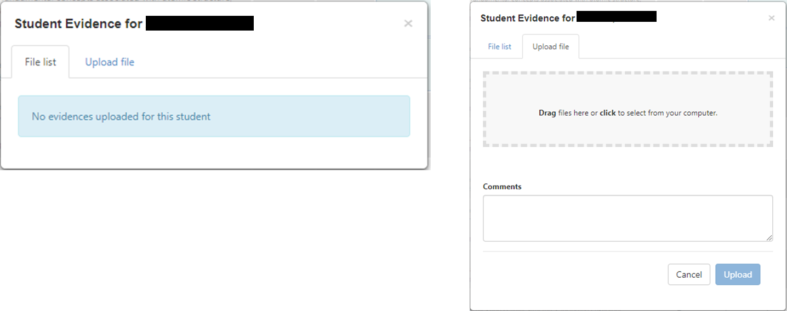

You can either drag and drop your file or use your computer file directory to attach your pdf. If you wish you can also make comments about what you are uploading. When you have, click “Upload” and you are done!
NOTES: You can upload more than one file per student. Just click on the file folder for that student again and upload another file!

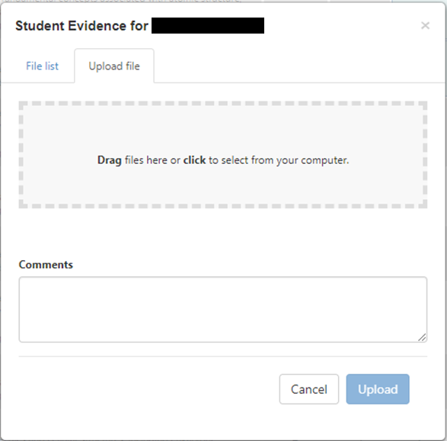

- Once you have completed your scoring, complete the Section Improvement Plan by clicking on "Save and Continue to Reflection.”
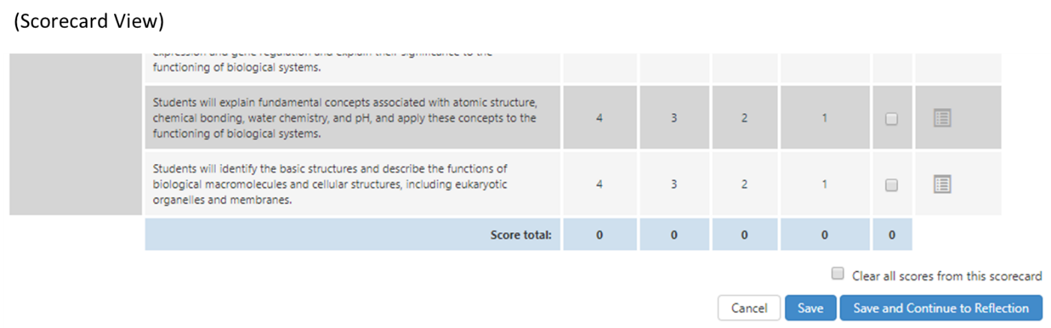

- Complete the 3 question prompts. Then click “Submit and Share” or “Submit and Share Anonymously.” Your department will decide if they want submissions identified by section.

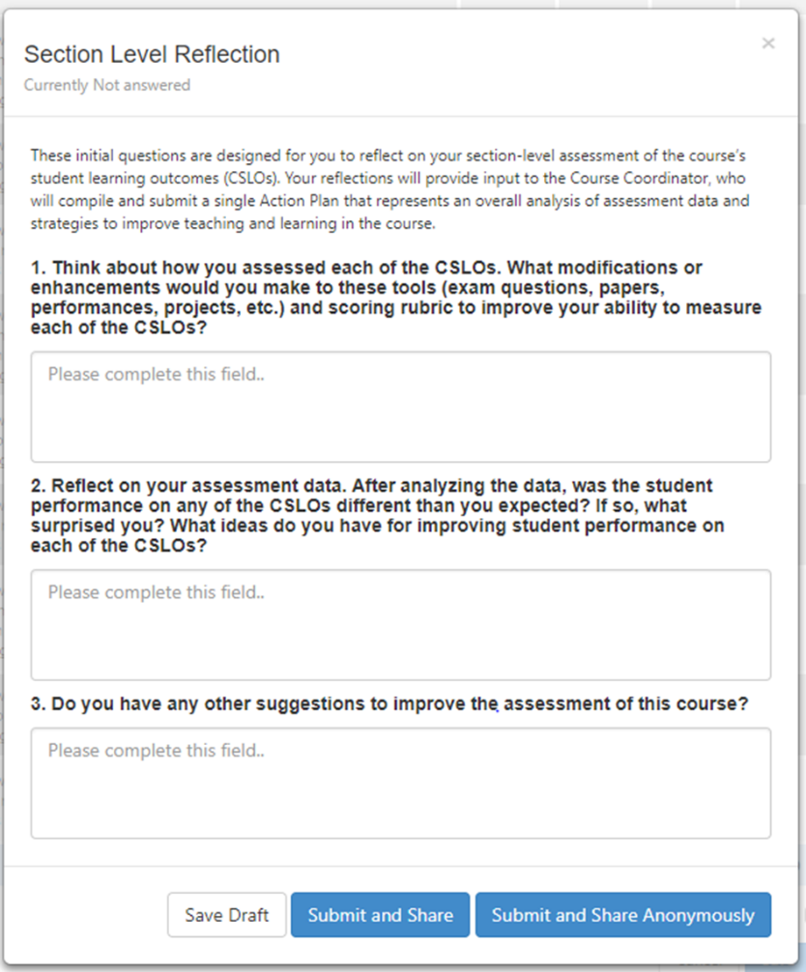

*If you do not see the correct information listed, or for questions or assistance, contact:
Assessment and Planning Office
Donna Clifford | Melissa Deadmond
dclifford@tmcc.edu | mdeadmond@tmcc.edu
775-673-7120 | 775-337-5649

