

*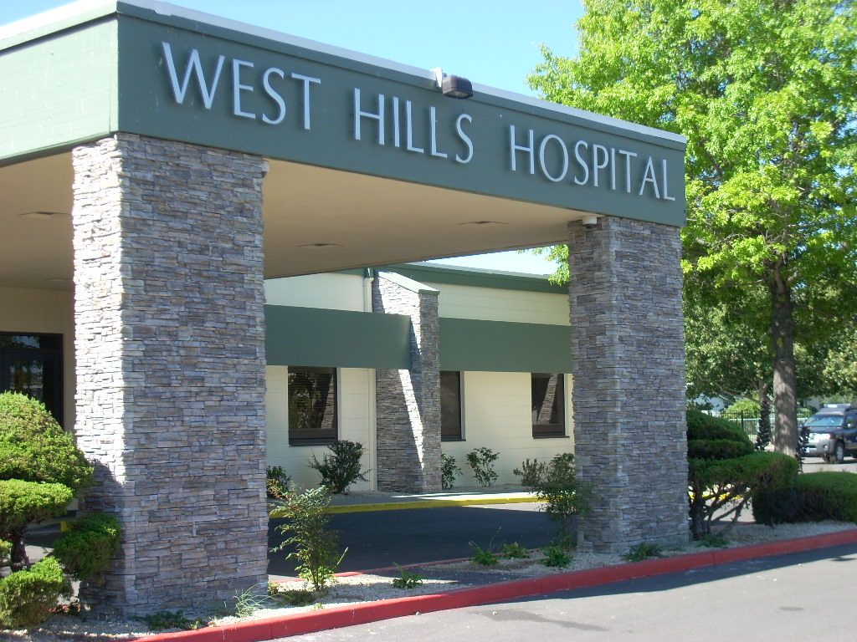.*

**MEETING SCHEDULE**

***Mental Health I Co-Occurring IOP***

* **Tuesday, Wednesday, Thursday**
* **5:30pm-8:30pm**
* **Dinner provided**

***Mental Health II IOP (Acute Mental Health)***

* **Tuesday, Wednesday, Thursday**
* **11:00am-2:00pm**
* **Transportation and Lunch Provided**

***Chemical Dependency IOP***

* **Monday, Tuesday, Thursday**
* **9:00am-12:00pm**
* **Transportation and Breakfast Provided**

**For more information, please contact Jeanette Bussey, Director of Outpatient Services at 775-789-4248 or by email at Jeanette.bussey@uhsinc.com**

**Intensive Outpatient Program Schedule**

**West Hills Hospital is now offering three Intensive Outpatient groups provided by expert clinicians. The curriculum includes process and educational group discussions. Groups focus on life skills training, recovery skills, communication and relationship skills and relapse prevention plans.**

**Our services are designed to provide a smooth transition from inpatient to home, or to help prevent the need for an inpatient admission. Our caring staff will work with you to help you be successful with your mental health treatment goals and your life in general.**

**Additional resources and referrals will be discussed as appropriate.**

**1240 E. Ninth St., Reno NV 89512**

**775-323-0478~800-242-0478**

